Grazioso Salvare Animal Rescue Dashboard README

About the Project

This project implements an interactive data dashboard designed for Grazioso Salvare. The company specializes in training dogs for search-and-rescue operations. The dashboard connects to a MongoDB database containing the Austin Animal Center (AAC) dataset and provides a clean way to explore animal records.

The goal of the dashboard is to help to quickly identify animals that meet specific rescue-training criteria. The dashboard displays:

A searchable, filterable data table

A pie chart showing breed distribution

An interactive map that updates when a row is selected

Radio-button filters for three rescue categories

This tool allows rescue coordinators to make faster, more informed decisions about which animals are suitable for specialized training programs.

Motivation

Grazioso Salvare needs a way to evaluate large volumes of animal intake data. Manually sorting through thousands of records is inefficient and prone to error. By combining:

A CRUD Python module

A MongoDB database

A Dash/JupyterDash dashboard,

the organization gains a centralized interface that supports real-time filtering, visualization, and exploration of the AAC dataset.

The dashboard improves decision-making by:

Highlighting animals that meet rescue-training criteria

Visualizing breed distribution trends

Allowing quick comparisons between filtered groups

Providing a map view for geographic context

This project demonstrates how client/server development, data visualization, and CRUD operations can work together to solve a real-world problem.

.

Getting Started
To get started with this project, you first need to set up your MongoDB environment by installing MongoDB locally and importing the AAC dataset into a database named aac with a collection called animals. After the data is loaded, create a MongoDB user with the appropriate read/write permissions and update the CRUD Python module with your own username and password so the dashboard can authenticate properly. Once the database is configured, make sure all required Python libraries are installed, including Dash, JupyterDash, pandas, plotly, pymongo, and dash-leaflet. These tools work together to support the dashboard’s interactive features, data visualization, and database communication.

From here, place the CRUD module in the same directory as your dashboard notebook so the import statement resolves correctly. When everything is in place, open the notebook in JupyterLab, run each cell in order, and launch the dashboard using app.run_server() command. The dashboard will open in a preview window, allowing you to explore the data, apply filters, and interact with the visualizations.

Installation
To build and test the module the following required installation:
- Python 3- Main language of the module
- MongoDB Community Server- stores the AAC data
- PyMongo- allows for cross communication between Python and MongoDB
- Jupyter Notebook- used for testing and building the interactive dashboard
- Plotly Express- generates the pie chart
- Dash Leaflet- generates the interactive map
- Pandas- converts MongoDB into DataFrames

Usage
The dashboard is designed to be simple and intuitive for users at Grazioso Salvare. When the application launches, the user is presented with the full interface, including the organization’s logo, the filter options, the interactive data table, the breed distribution pie chart, and the geographic map. The user can begin by selecting one of the three rescue-training filters—Water Rescue, Mountain/Wilderness Rescue, or Disaster/Tracking—to instantly narrow the dataset to animals that meet the criteria for that specific training category. Each filter automatically updates both the data table and the pie chart, allowing the user to visually compare breed distributions across different rescue types. The Reset option returns the dashboard to the full dataset.

The data table is fully interactive, and selecting any row triggers an update to the map below. When a row is clicked, the map centers on the corresponding location and displays a marker with a tooltip and popup containing the animal’s name and breed information. This allows users to quickly understand where the animal was found or processed, adding geographic context to the selection process. The combination of filters, visualizations, and map interaction provides a complete, user-friendly experience for exploring the AAC dataset.

Below are the following screenshots of the dashboard functions:

Full Dashboard View
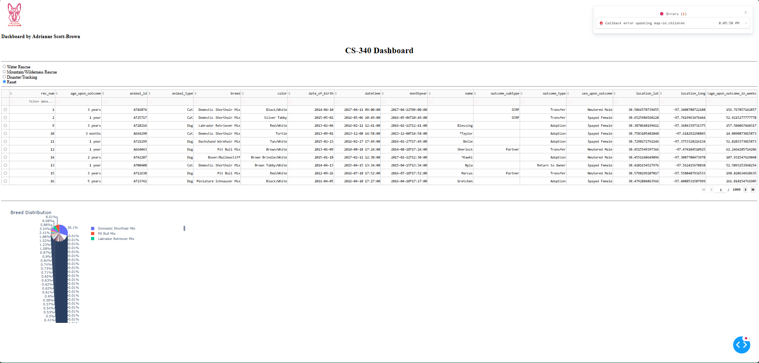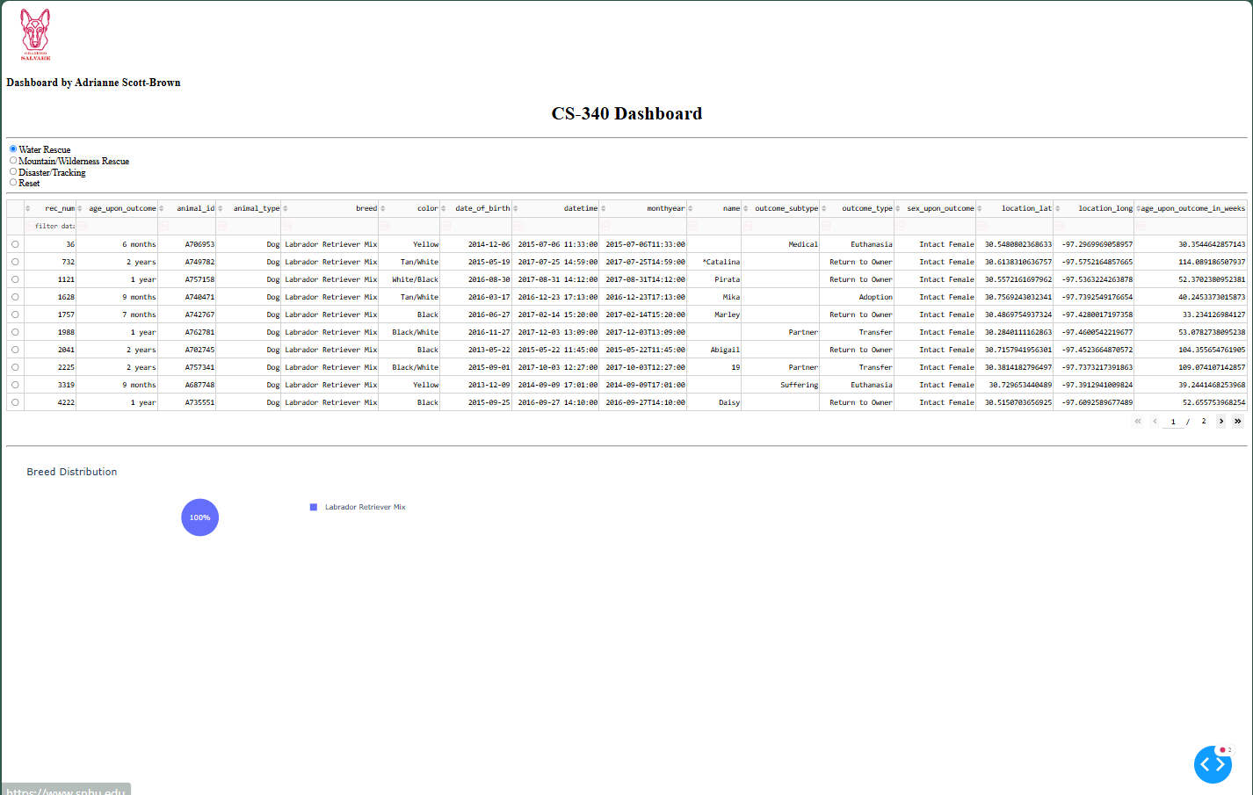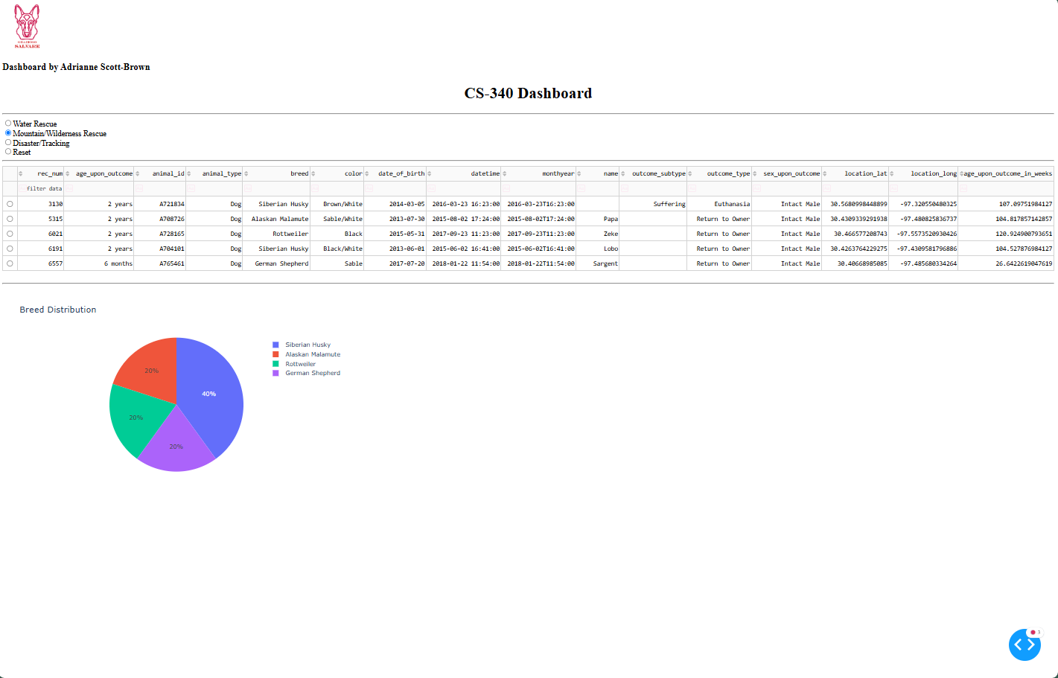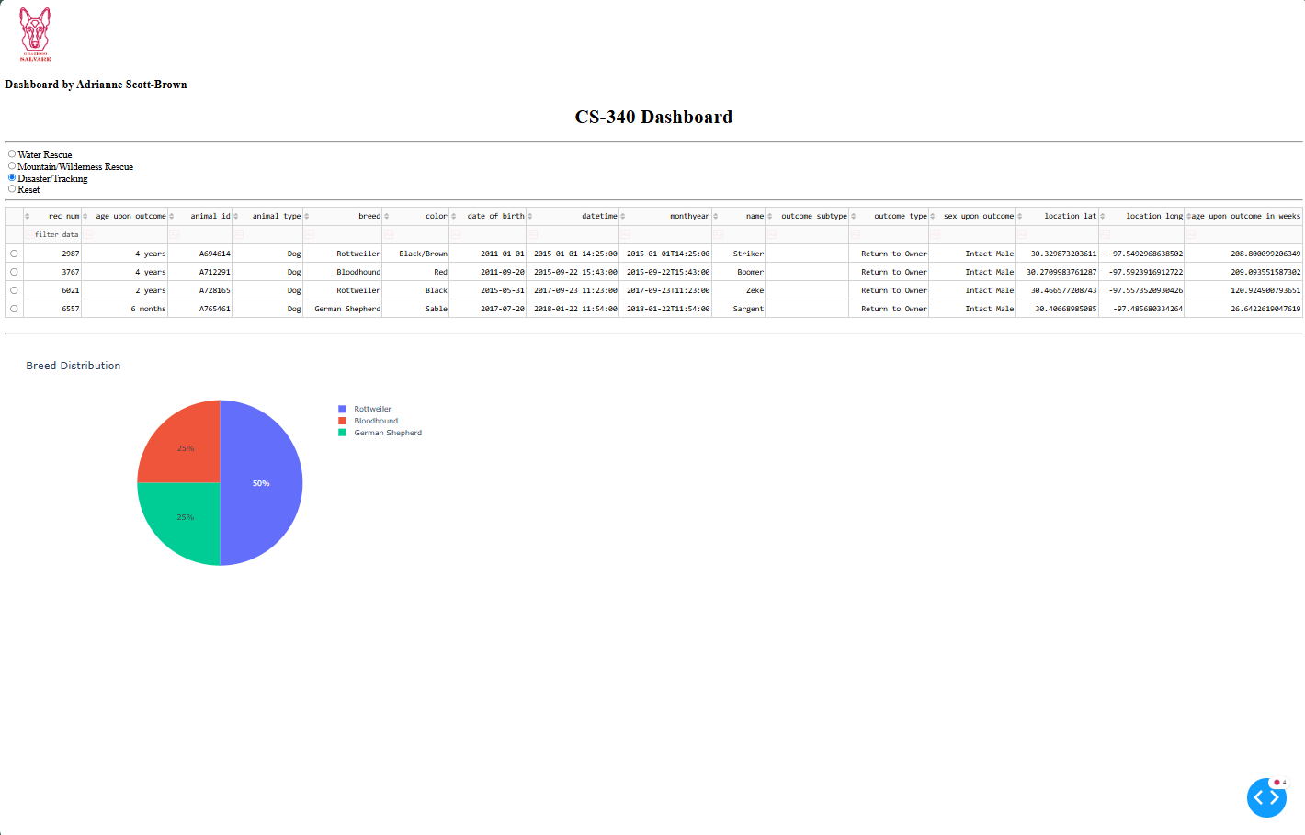

Contact
Your name: Adrianne Scott-Brown

